Java Assignments

Day 3 (13-01-2021)

1. do{

Online Examination

1:English , 2 : Math 3 : GK

switch() {

case 1

3 Q

case 2

3 Q

case 3

3 Q

}

Do want to continue ?

}while();

Ans: import java.util.Scanner;

class StudentExam

{

public static void main(String args[])

{

int p=0,q=0,r=0,s=0;

do

{

Scanner sc=new Scanner(System.in);

System.out.println("Enter Exam options");

System.out.println("1.English");

System.out.println("2.Math");

System.out.println("3.GK");

int id=sc.nextInt();

int out1=10;

switch(id)

{

case 1:

if(p==1)

{

System.out.println("Already Attempted");

break;

}

else

{

p=1;

System.out.println("1.Q Hello..........");

System.out.println("1.World 2. Yes 3. No");

Scanner one=new Scanner(System.in);

int a1=one.nextInt();

if(a1==1)

{

s=s+out1;

}

System.out.println("2.Q Hey! My Name is .......");

System.out.println("1.Madhav 2.Raju 3.Ravi");

//Scanner one=new Scanner(System.in);

int a2=one.nextInt();

if(a2==1)

{

s=s+out1;

}

System.out.println("3.Q Janu went to........ tonoght!");

System.out.println("1.Party 2.Nighout 3.Home");

//Scanner one=new Scanner(System.in);

int a3=one.nextInt();

if(a3==1)

{

s=s+out1;

}

}

break;

case 2:

if(q==1)

{

System.out.println("Already Attempted");

break;

}

else

{

q=1;

System.out.println("1.Q Addition of 3+4");

Scanner two=new Scanner(System.in);

int b1=two.nextInt();

if(b1==7)

{

s=s+out1;

}

System.out.println("2.Q Addition of 12+3");

//Scanner two=new Scanner(System.in);

int b2=two.nextInt();

if(b2==15)

{

s=s+out1;

}

System.out.println("3.Q Multiplication of 2\*4");

//Scanner two=new Scanner(System.in);

int b3=two.nextInt();

if(b3==8)

{

s=s+out1;

}

}

break;

case 3:

if(r==1)

{

System.out.println("Already Attempted");

break;

}

else

{

r=1;

System.out.println("1.Q Prime Minister of India");

System.out.println("1.Manmohan Singh 2.Soniya Gandhi 3.Narendra Modi");

Scanner three=new Scanner(System.in);

int c1=three.nextInt();

if(c1==3)

{

s=s+out1;

}

System.out.println("2.Q CM of Andhra Pradesh");

System.out.println("1.Chandra Babu 2.Jagam 3.Koti");

//Scanner three=new Scanner(System.in);

int c2=three.nextInt();

if(c2==1)

{

s=s+out1;

}

System.out.println("3.Q Zensar was formed in");

System.out.println("1.1991 2.2000 3.2010");

//Scanner three=new Scanner(System.in);

int c3=three.nextInt();

if(c3==1)

{

s=s+out1;

}

}

break;

}

System.out.println("Do you want to continue y/n?");

Scanner yn=new Scanner(System.in);

char check=yn.next().charAt(0);

if(check=='y')

continue;

else

break;

}

while(p+q+r<3);

if(s>70)

{

s=s+10;

}

System.out.println(s);

}

}

OutPut: 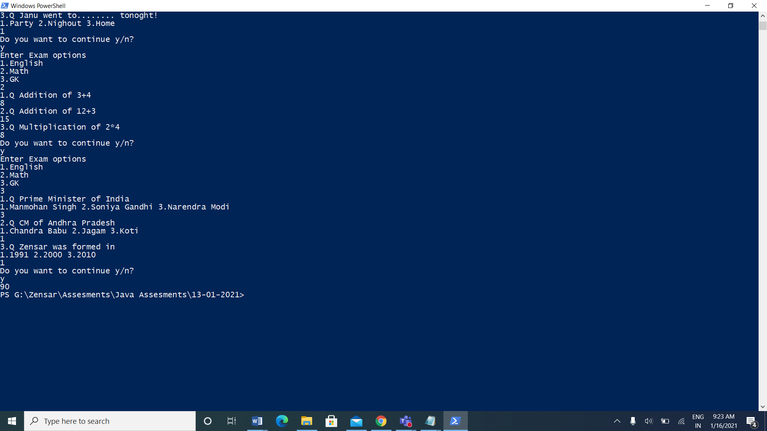

1. Take n number records through keyboards as Id,Name,Salary,Desg

(array id,name,salary,Desg).

Salary = salary + hra + da – pf;

Hra is 10% salary

Da is 7 % salary

Pf 5 % salary

If desg is manager desg.equals(“Developer”)

15% bonus

If developer 10% bonus

Else

5 % bonus

Id, name, salary( grossSalary +bonus ) and desg.

Ans: import java.util.\*;

class EmployeeDetails

{

int n;

public static void main (String[] args)

{

Scanner sc= new Scanner(System.in);

System.out.println("\n Enter total Entries: ");

int n=sc.nextInt();

int id[]=new int[n];

String name[]=new String[n];

double sal[]= new double[n];

String desg[]=new String[n];

for(int i=0;i<n;i++)

{

System.out.println("Enter Id: ");

id[i]=sc.nextInt();

System.out.println("Enter Name: ");

name[i]=sc.next();

System.out.println("Enter Designation: ");

System.out.println("1.Manager 2.Developer 3.Associate");

desg[i]=sc.next();

if(desg[i].equals(1))

{

System.out.println("Hello Manager!");

}

if(desg[i].equals(2))

{

System.out.println("Hello Developer");

}

else{

System.out.println("Hello Associate");

}

System.out.println("\n Enter Salary: ");

sal[i]=sc.nextDouble();

}

for(int i=0;i<n;i++)

sal[i] += 10\*sal[i]/100 + 7\*sal[i]/100 - 5\*sal[i]/100;

for(int i=0;i<n;i++)

{

if(desg[i].equals("Manager"))

sal[i] += sal[i]\*15/100;

else if(desg[i].equals("manager"))

sal[i] += sal[i]\*15/100;

else if(desg[i].equals("Developer"))

sal[i] += sal[i]\*10/100;

else if(desg[i].equals("developer"))

sal[i] += sal[i]\*10/100;

else

sal[i] += sal[i]\*5/100;

}

System.out.println("Total Number of Employees:"+n);

System.out.println(" \*\*\*\*\*Employee Details\*\*\*\*\*");

for(int i=0;i<n;i++)

{

System.out.println("Employee ID:"+id[i]);

System.out.println("Name:"+name[i]);

System.out.println("Salary:"+sal[i]);

System.out.println("Designation:"+desg[i]);

System.out.println("++++++++++++++++++++++++++++++++");

}

}

}

OutPut: 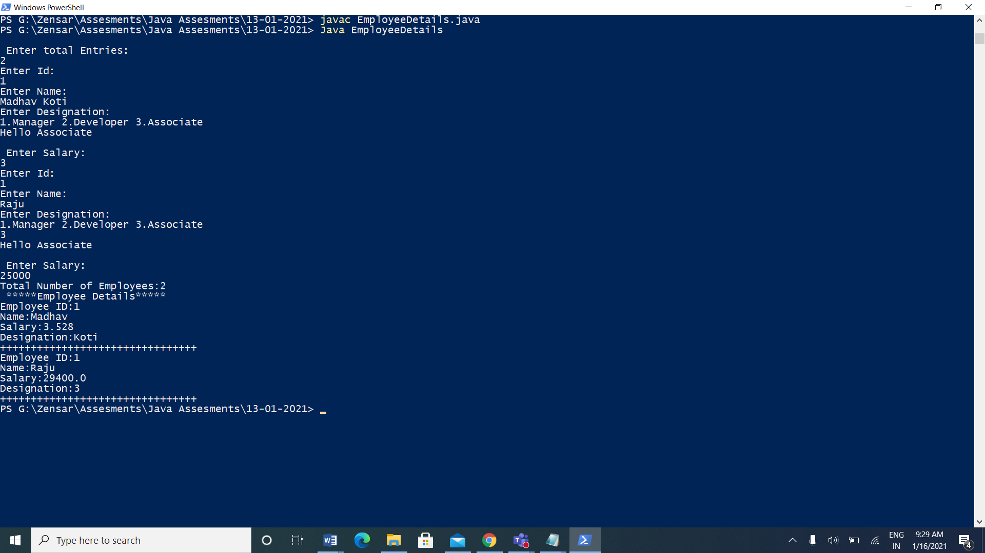

1. Create EmployeeDetails class with 4 instance array variables.

EmployeeDetails() : memory size for array id,name,salary, desg must assign in constructor at run time.

read()

read all employee id,name,salary,desg

calSalary()

hra, da, pf local variables.

calculate salary

bonus()

apply bonus

display()

display details

EmployeeTest :

Main methods

Object creation

And calling all methods

Take n number records through keyboards as Id,Name,Salary,Desg

(array id,name,salary,Desg).

Salary = salary + hra + da – pf;

Hra is 10% salary

Da is 7 % salary

Pf 5 % salary

If desg is manager

15% bonus

If developer 10% bonus

Else

5 % bonus

Id, name, salary( grossSalary +bonus ) and desg

Ans: import java.util.Scanner;

class EmployeeDetails

{

Scanner sc=new Scanner(System.in);

int n;

EmployeeDetails(int size)

{

n=size;

id=new int [size];

name=new String [size];

salary=new float [size];

salarycpy=new float[size];

desg=new String [size];

}

int []id;

String []name;

float []salary;

float []salarycpy;

String []desg;

void read()

{

for(int i=0;i<n;i++)

{

System.out.println("Enter id ");

id[i]=sc.nextInt();

sc.nextLine();

System.out.println("Enter name ");

name[i]=sc.nextLine();

System.out.println("Enter salary ");

salary[i]=sc.nextFloat();

salarycpy[i]=salary[i];

sc.nextLine();

System.out.println("Enter designation ");

desg[i]=sc.nextLine();

System.out.println("\n");

}

}

void calsalary()

{

for(int k=0;k<n;k++)

{

float hra,da,pf;

hra=salary[k]\*0.1f;

da=salary[k]\*0.07f;

pf=salary[k]\*0.05f;

salary[k]=salary[k]+hra+da-pf;

}

}

void bonus()

{

for(int k=0;k<n;k++)

{

salary[k]=salarycpy[k];

float hra,da,pf;

hra=salary[k]\*0.1f;

da=salary[k]\*0.07f;

pf=salary[k]\*0.05f;

if(desg[k].equals("manager"))

{

salary[k]=(salary[k]+hra+da-pf)+(salary[k]\*0.15f);

}

else if(desg[k].equals("developer"))

{

salary[k]=(salary[k]+hra+da-pf)+(salary[k]\*0.1f);

}

else

{

salary[k]=(salary[k]+hra+da-pf)+(salary[k]\*0.05f);

}

}

}

void display()

{

for(int k=0;k<n;k++)

{

System.out.println("Details of Employee:"+(k+1));

System.out.println("id="+id[k]);

System.out.println("Name="+name[k]);

System.out.println("Salary="+salary[k]);

System.out.println("Designation="+desg[k]);

}

}

}

class Employee

{

public static void main(String args[])

{

Scanner sc=new Scanner(System.in);

System.out.println("Enter Number of records you want to store:");

int x=sc.nextInt();

EmployeeDetails empd=new EmployeeDetails(x);

empd.read();

empd.calsalary();

empd.bonus();

empd.display();

}

}

Output:

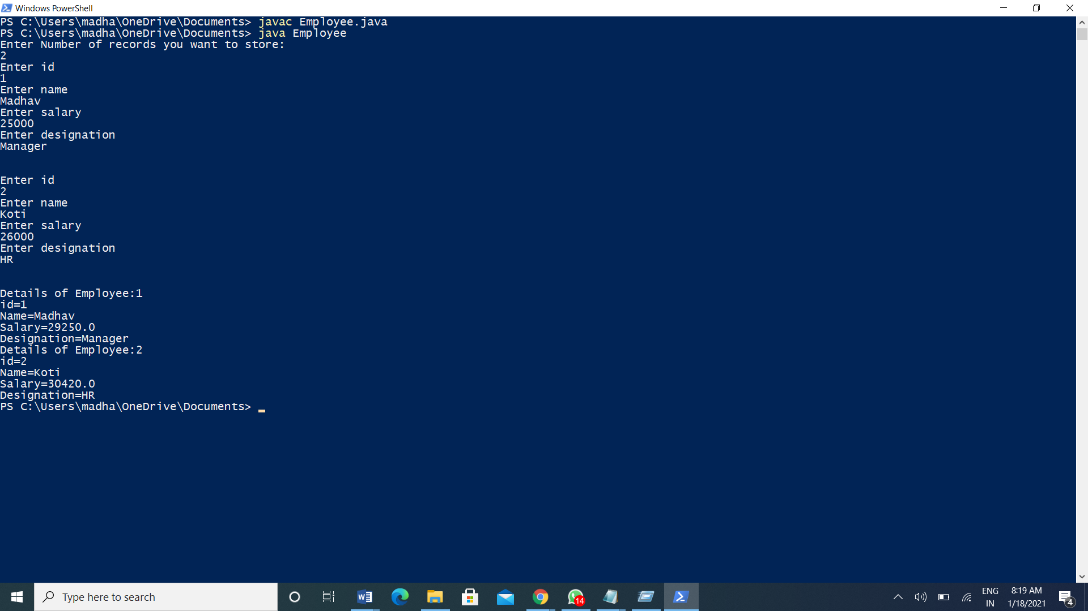

1. Manager / Programmer is a Employee

Employee has a Address

class Employee { super class must be generic

id,name,salary

Scanner obj = new Scanner(System.in);

Address add = new Address();

methods

read() id,name,salary

, calSalary() : hra, da and pf

dislay()

}

class Manager extends Employee { sub must be specific

numberOfEmp : numbers

readMgr() numberOfEmp

add.readAdd();

disMgr();

numberOfEmp

add.disAdd();

}

class Programmer extends Employee{ sub must be specific

projectName: string

readPrg()

projectName

add.readAdd();

disPrg();

}

class Address {

city, state, pinCode

Scanner obj = new Scanner();

readAdd()

read city,state and pincode

disAdd();

city, state and pincode

}

EmployeeTest

Main Don’t create the Employee class object.

S.O.P(ManagerDetails);

Manager mgr

mgr.read() 3 details

mgr.readMgr() 1 own details, 3 address details

S.O.P(ProgramerDetails)

Programmer prg

prg.read()

prg.readPrg()

mgr.calSalary();

prg.calSalary()

Display Manager and Programmer details.

Ans: import java.util.\*;

class Employee

{

int id;

String name;

float salary;

Scanner sc=new Scanner(System.in);

Address add=new Address();

void read()

{

System.out.println("Enter id:");

id=sc.nextInt();

sc.nextLine();

System.out.println("Enter Name:");

name=sc.nextLine();

System.out.println("Enter salary:");

salary=sc.nextFloat();

}

void calsalary()

{

float hra,da,pf;

hra=salary\*0.1f;

da=salary\*0.07f;

pf=salary\*0.05f;

salary=salary+hra+da-pf;

}

void display()

{

System.out.println("\n");

System.out.println("Id="+id);

System.out.println("name="+name);

System.out.println("salary="+salary);

}

}

class Manager extends Employee

{

int number;

void readmgr()

{

System.out.println("Enter Number of Employee:");

number=sc.nextInt();

add.readadd();

}

void dismgr()

{

System.out.println("Number of Employee="+number);

add.disadd();

}

}

class Programmer extends Employee

{

String projectname;

void readprg()

{

sc.nextLine();

System.out.println("Enter name of project:");

projectname=sc.nextLine();

add.readadd();

}

void disprg()

{

System.out.println("Project="+projectname);

add.disadd();

}

}

class Address

{

String city,state;

int pincode;

Scanner obj=new Scanner(System.in);

void readadd()

{

System.out.println("Enter city:");

city=obj.nextLine();

System.out.println("Enter state:");

state=obj.nextLine();

System.out.println("Enter pincode:");

pincode=obj.nextInt();

}

void disadd()

{

System.out.println("city="+city);

System.out.println("state="+state);

System.out.println("pincode="+pincode);

}

}

class Employeetesting

{

public static void main(String args[])

{

System.out.println("Manager Details");

Manager mgr=new Manager();

mgr.read();

mgr.readmgr();

System.out.println("Programmer Details");

Programmer prg=new Programmer();

prg.read();

prg.readprg();

mgr.calsalary();

prg.calsalary();

mgr.display();

mgr.dismgr();

prg.display();

prg.disprg();

}

}

Output: 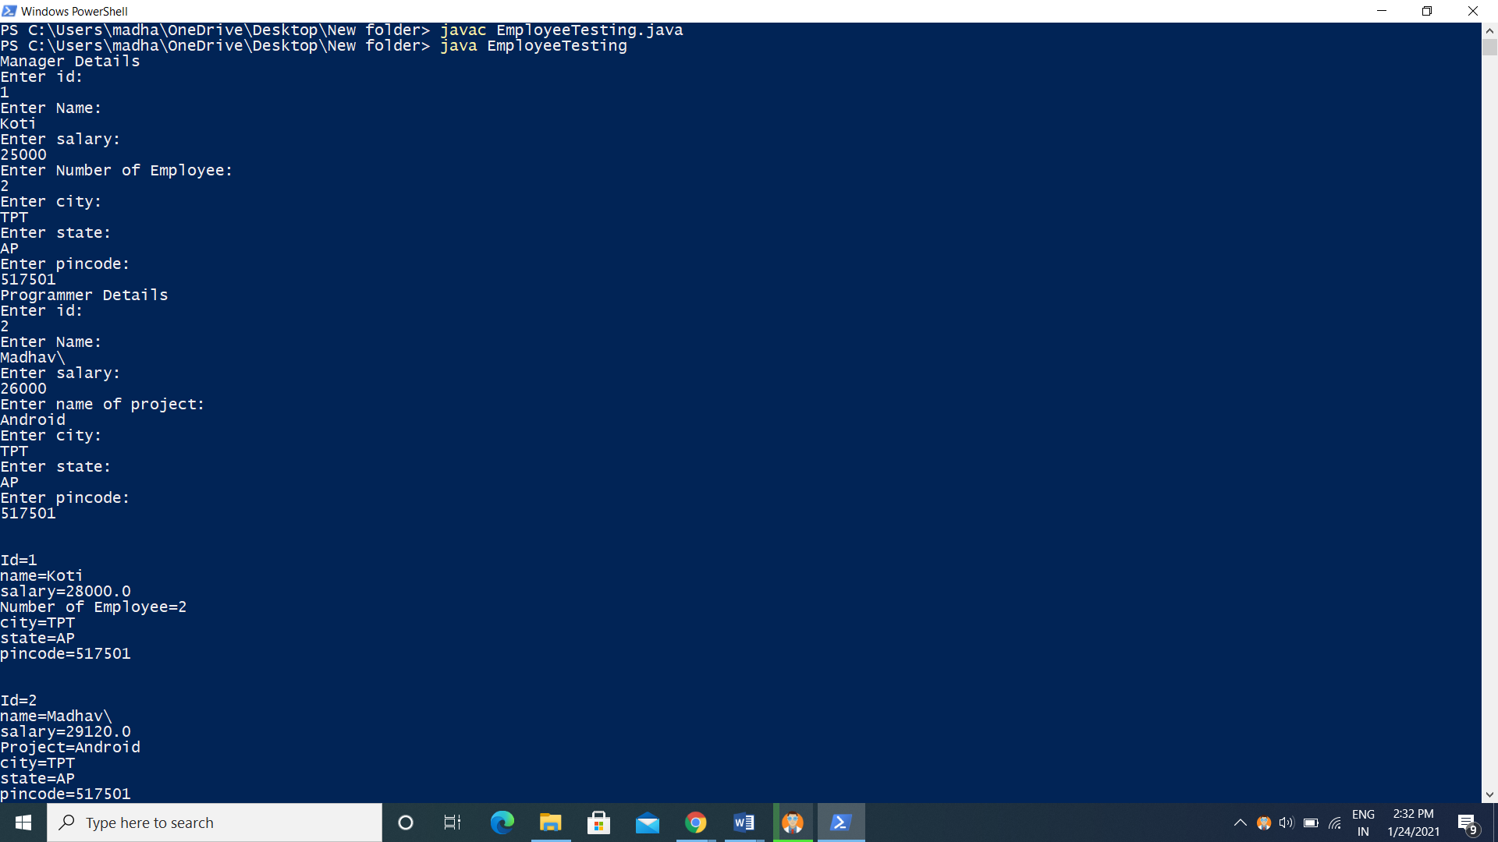

Assignment 5:

Create Student class which contains sId,SName,Age,Marks[](PCMB) ,Grade(char)

Scanner obj

read()

take

id

name,

age

for(i=0;iM<marks.length;i++) {

marks[i]=obj.next()

}

calculateGrade()

local variable total,avg;

avg > 90 A+

avg >80 A

avg >70 B

avg >55 C

else

D

display

id,name,age,Grade

StudentTest

Create Student array object

How many student details do you want to store.

Student std[]=new Students[n];

for(int i=0;i<n;i++) {

std[i]=new Student();

std[i].read();

}

for(int i=0;i<i++){

std[i].calculateGrade();

}

for(int i=0;i<i++){

std[i].display();

}

Ans: import java.util.Scanner;

class Student {

int sid,age;

String sname;

int marks[]=new int[4];

int m1,m2,m3,m4;

float total=0;

Scanner sc = new Scanner(System.in);

char grade;

void read(){

System.out.println("enter Student id: ");

sid=sc.nextInt();

sc.nextLine();

System.out.println("Enter Student name: ");

sname=sc.nextLine();

System.out.println("Enter Student age: ");

age=sc.nextInt();

System.out.println("Enter Student marks: ");

for(int i=0;i<marks.length;i++) {

marks[i]=sc.nextInt();

total=total+marks[i];

}

}

void calculategrade() {

float totalavg;

totalavg=(total/4);

if(totalavg>90) {

grade='A'

}

else if(totalavg>=80) {

grade='B';

}

else if(totalavg>=70) {

grade='C';

}

else if(totalavg>=55) {

grade='D';

}

else {

grade='E';

}

System.out.println(grade);

}

void display() {

System.out.println("\*\*\*\*\*\*\*\*\*\*\*\*\*\*\*\*\*\*\*\*\*\*\*" );

System.out.println("sid="+sid);

System.out.println("sname="+sname);

System.out.println("age="+age);

System.out.println("grade"+grade);

}

}

class StudentTest{

public static void main(String args[]) {

Scanner sc= new Scanner(System.in);

System.out.println("Enter Number of Entries: ");

int n = sc.nextInt();

Student std[]=new Student[n];

for(int i=0;i<n;i++) {

std[i]=new Student();

std[i].read();

}

for(int i=0;i<n;i++) {

std[i].calculategrade();

}

for(int i=0;i<n;i++) {

std[i].display();

}

}

}

Output: 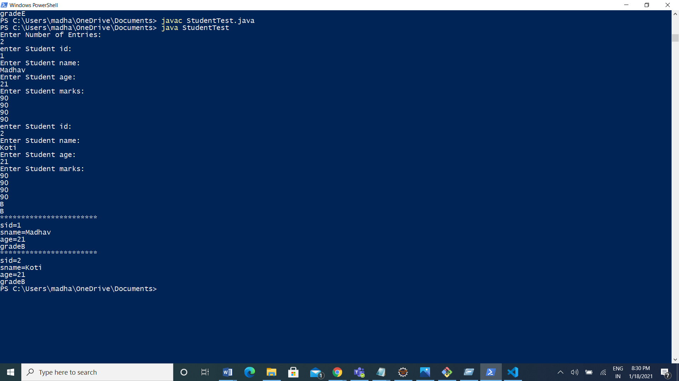

Mini Project 6:



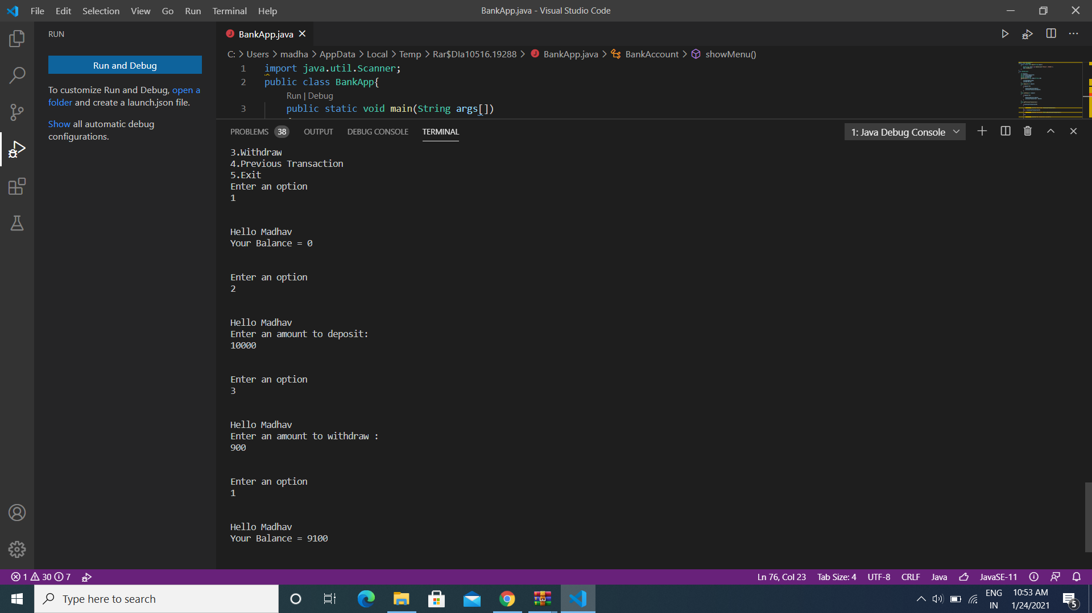

Assignment 7:

Take n number of names through keywords and display those names in ascending or descending order. (Ignore case sensitive).

String names[]={“Raj”,”ravi”,”Akash”,”ajay”};

Ans: import java.util.\*;

public class StringDemo {

public static void main(String[] args) {

Scanner sc=new Scanner(System.in);

System.out.println("Enter number of strings to be Entered:");

int n=sc.nextInt();

String []str=new String[n];

System.out.println("Enter strings:");

for(int i=0;i<n;i++)

{

str[i]=sc.next();

}

for(int i=0;i<n;i++)

{

for(int j=0;j<n;j++)

{

String str1 = str[i];

String str2 = str[j];

int c=str1.compareToIgnoreCase(str2);

if(c<0)

{

String str3=str[j];

str[j]=str[i];

str[i]=str3;

}

}

}

for(int i=0;i<n;i++)

{

System.out.println(str[i]);

}

}

}

OutPut:

